

# MINI PROJECT REPORT

## ON

# SNAKE GAME USING CSS, HTML AND JAVASCRIPT

Submitted for the partial fulfillment of award of

### BACHELOR OF TECHNOLOGY

**In**

**Computer Science & Engineering**

**Himanshu Bhati (2002220100070)**

**Kumari Manasi (2002220100082)**

**Jaivrat Lohiya (2002220100075)**

**SESSION:2021-22**

**Submitted to:**

**Ms. Varsha Singh**

**INDEX:**

|  |  |  |
| --- | --- | --- |
| S. No. | Topic | |
| 1. | Declaration | |
| 2. | Abstract | |
| 3. | Acknowledgement | |
| 4. | Introduction of Project | |
| 5. | Requirements for Project Making | |
| 6. | Hardware Used | |
| 7. | Testing and Evaluation | |
| 8. | Project Snapshots | |
| 9. | Advantages and Limitations | |
| 10. | Future Scope |
| 11. | Conclusion | |
| 12. | Bibliography | |

**Delclaration**

We hereby declare that the work presented in this report entitled “SNAKE GAME USING CSS, HTML AND JAVASCRIPT” in fulfilment of the requirement for the third semester Investigatory Project, submitted in Mini Project Subject, I.T. S Engineering College, Greater Noida, is an authentic record of work carried out by my team and myself, during my third semester under the guidance of **Ms**. **Varsha Singh.**

The work reported in this has not been submitted for award of any other Certificate or diploma.

**Abstract**

The Nokia inspired Snake game implemented on 8051 platform. The game is built on AT89S51 Microcontroller. The game uses an 8 * 8 LED dot matrix display and five-way keys for user interface. A dedicated delay settings key provides one touch access to the delay settings mode where the speed of the Snake can be adjusted.

In our project we are implementing the snake game by using microcontroller. In this we are using switches one is Start for starting of the game and remaining switches for snake movements left, right, up and down these switches used like as a buttons in mobile. We are going to develop coding by using Embedded C according to that coding by using dot matrix the snake and egg will be display on 8*8 dot-matrix and by using switches the game will be operate according to our requirement.

Snake game is a computer action game, whose goal is to control a snake to move and collect food in a map.

In this paper we develop a controller based on movement rating functions considering smoothness, space, and food. Experimental results show that our design method is able to generate smart controllers.

**Acknoledgement**

It gives us a great sense of pleasure to present the Report of the Project “Snake Game Using CSS, HTML, and JAVASCRIPT” undertaken during B. Tech second Year. First and foremost, we wish to thank our Guide Ms. Varsha Singh **(Department of Computer Science and Engineering, I.T.S. Engineering College Greater Noida)** for his kind blessings to us.

We also do not like to miss the opportunity to acknowledge the contribution of all faculty members of the Department for their kind assistance and cooperation during the development of our project.

Many people, especially my classmates and friends themselves, have made valuable comments and suggestions on this proposal which gave me inspiration to improve my project. Here, we thank all the people for their help directly and indirectly to complete this project report.

**introduction of project**

This project has been built in the following manner.

1.The main structure has been built using html.

2.The styling has been done using CSS.

3.The main coding of how the Code should work has been done using JS.

We would look into detail about above point in the coming Pages.

**Hardware and software Used**

**Hardware:**

Dell Inspiron 14 Laptop

Intel i5 -11th gen

8 GB RAM

**Software:**

Windows 11

VS Code

**Testing and Evaluation:**

**Any software after completion of its development requires testing and evaluation. We also tested our CODE after the development. Following are the points we Found out during and after the testing and evaluation.**

* **The game has bug that sometimes the food gets generated over the body of the Snake.**
* **The game is not quite entertaining after playing it for some time, the player gets bored.**
* **The game does not have the rich features like Top 5 scores, selection of level, etc.**

**Snapshots:**

**CODE:**

**1.Main Structure:**

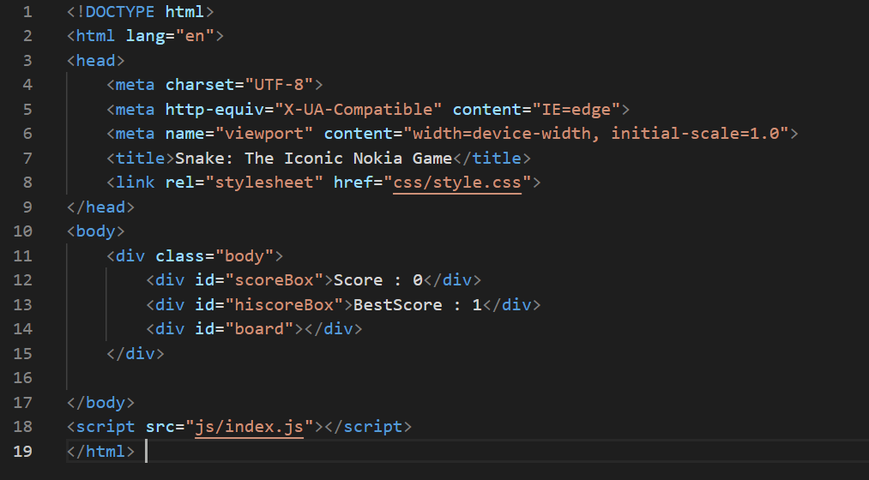

**2.Styling:**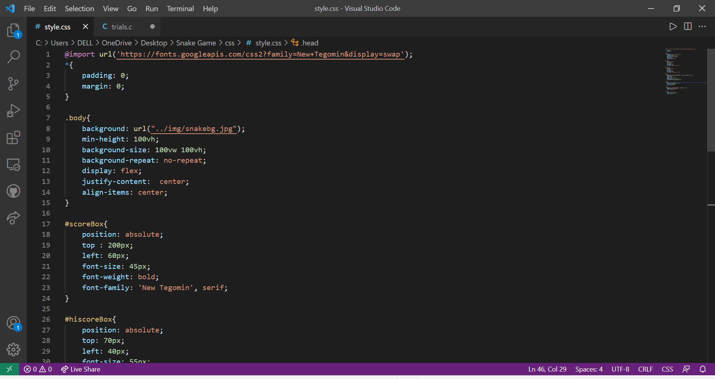

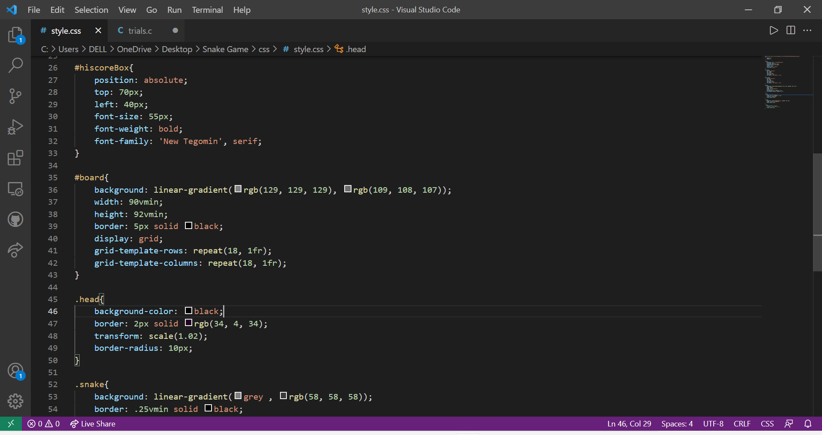

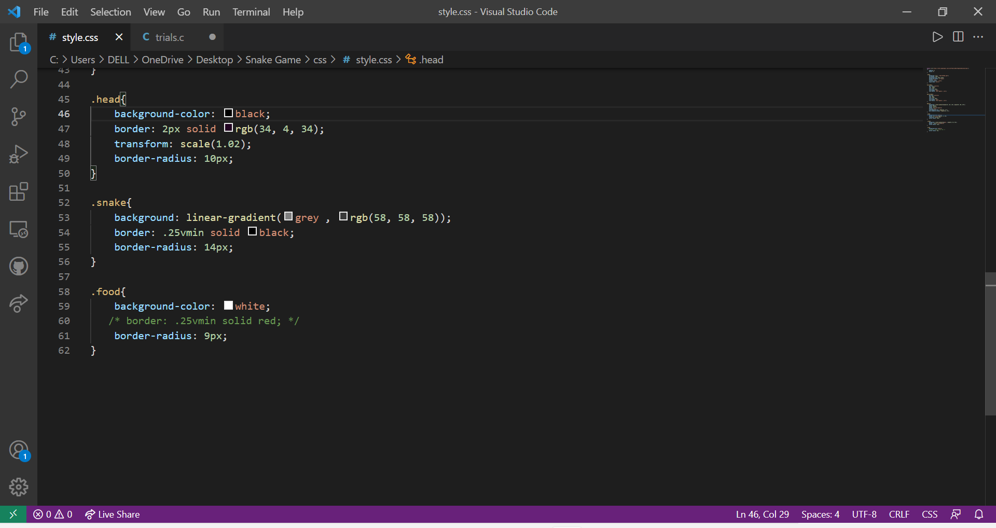

**3.Algorithmic part:**

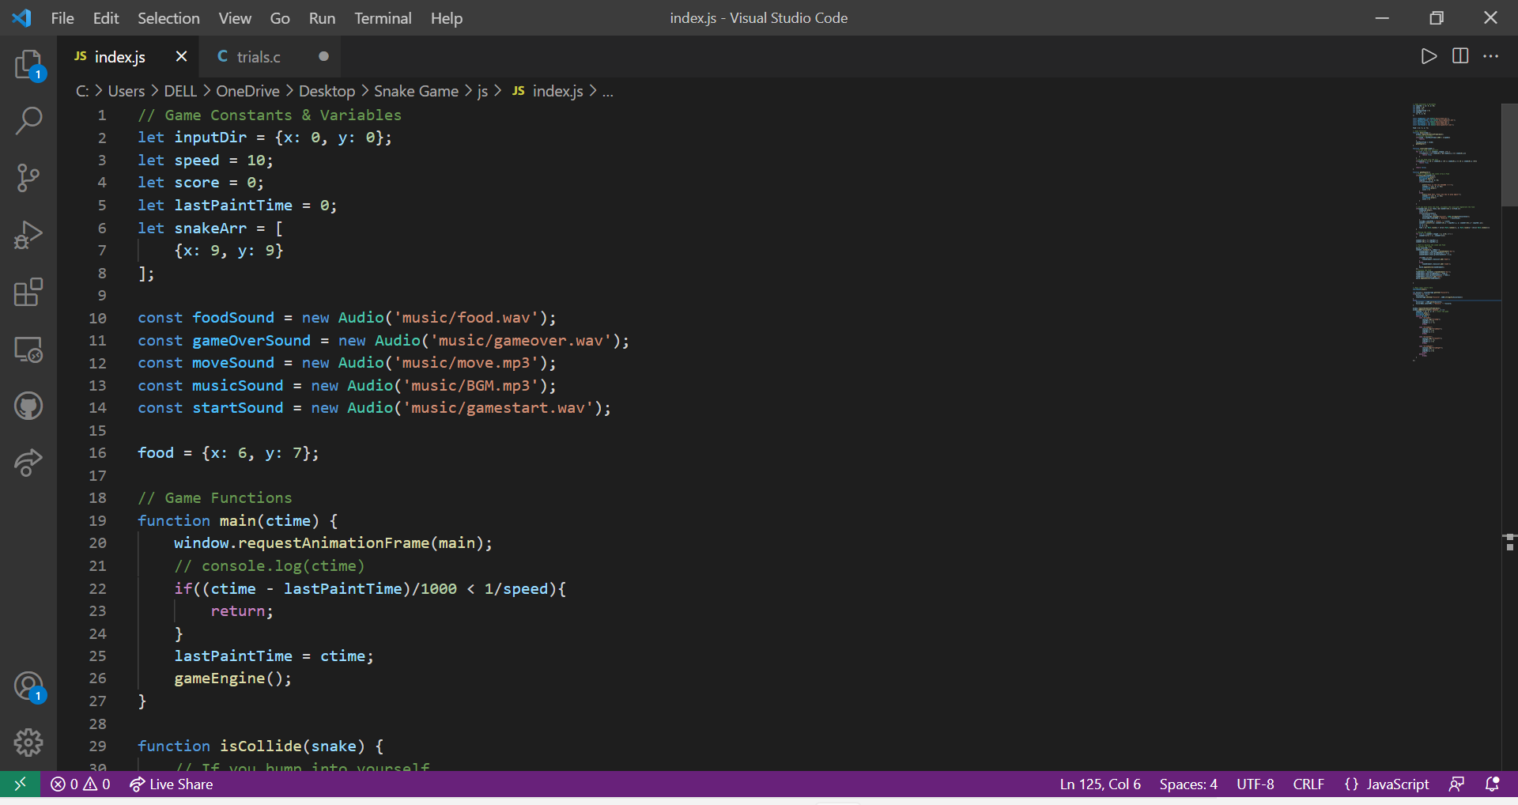

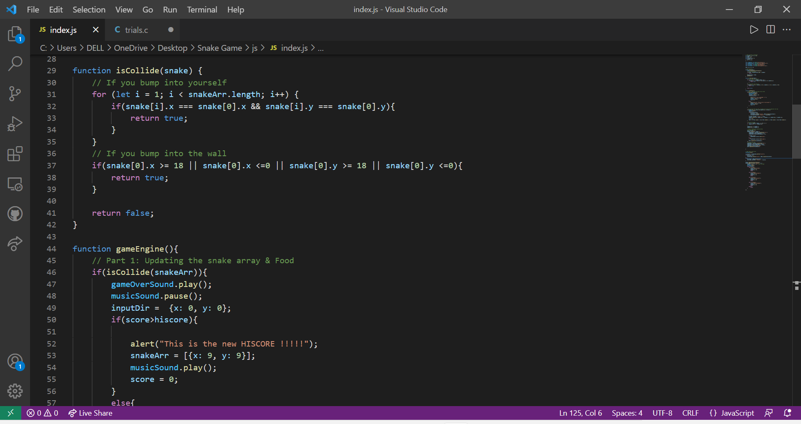

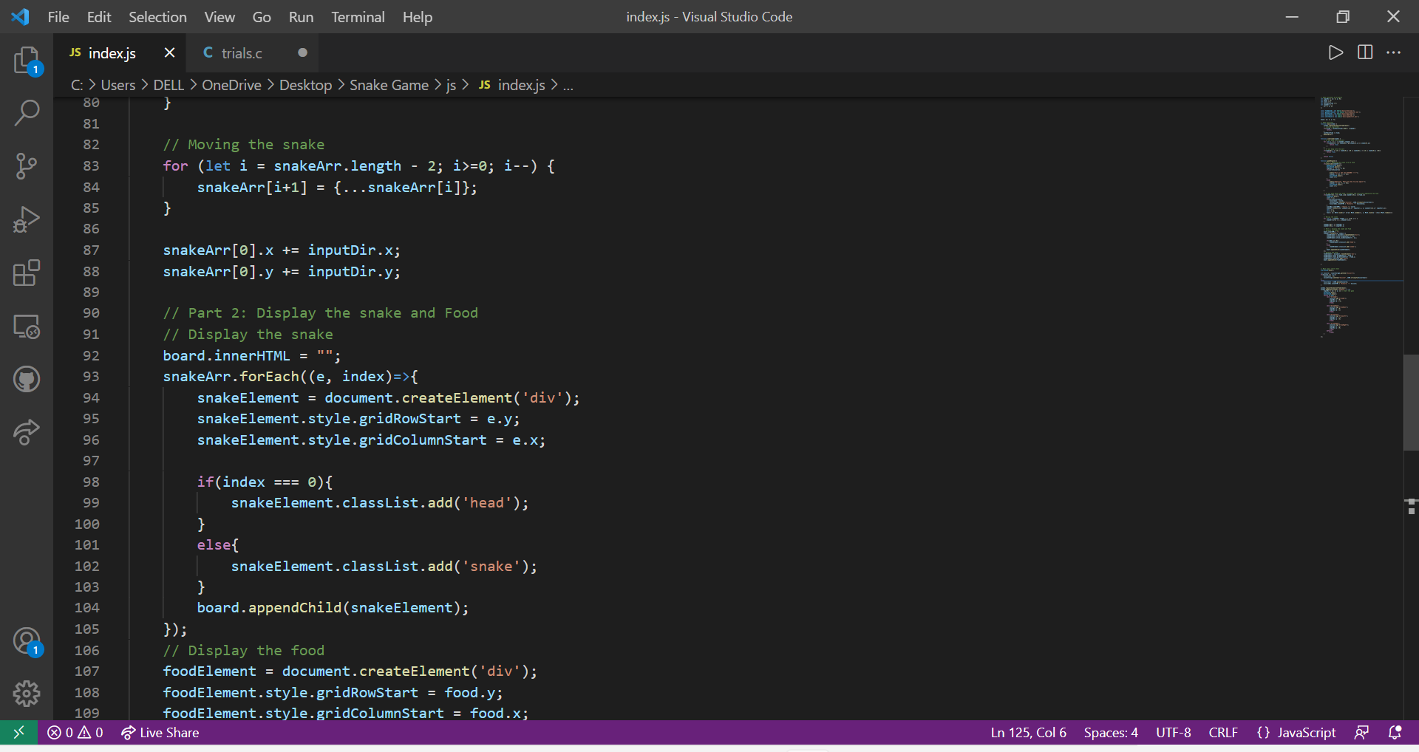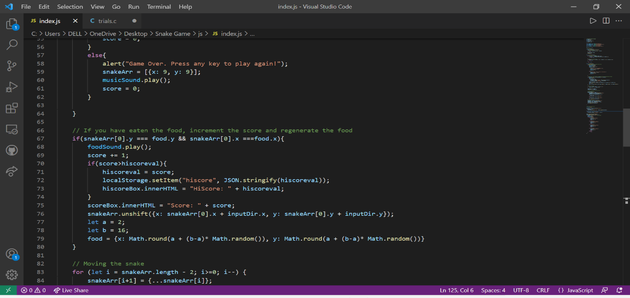

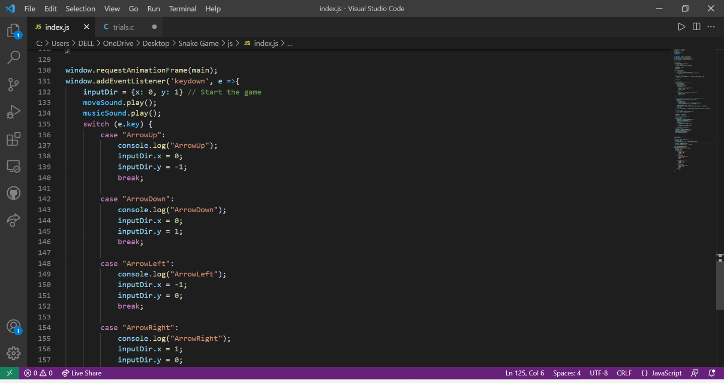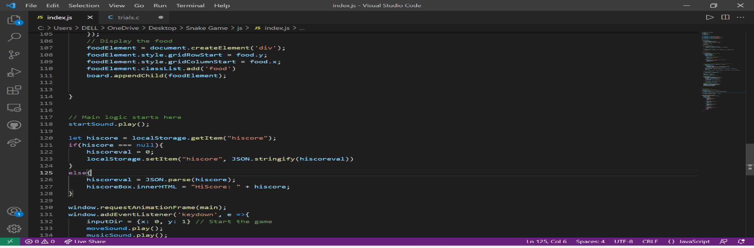

**OUTPUT:**

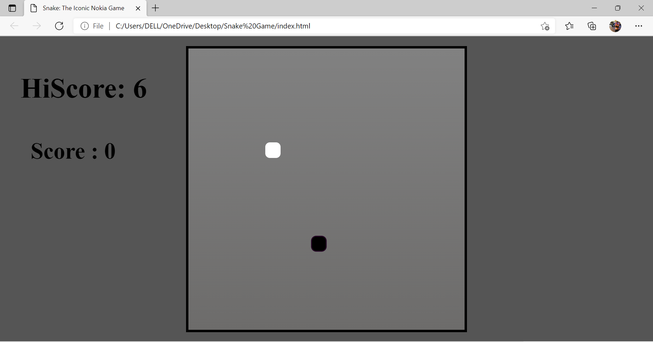

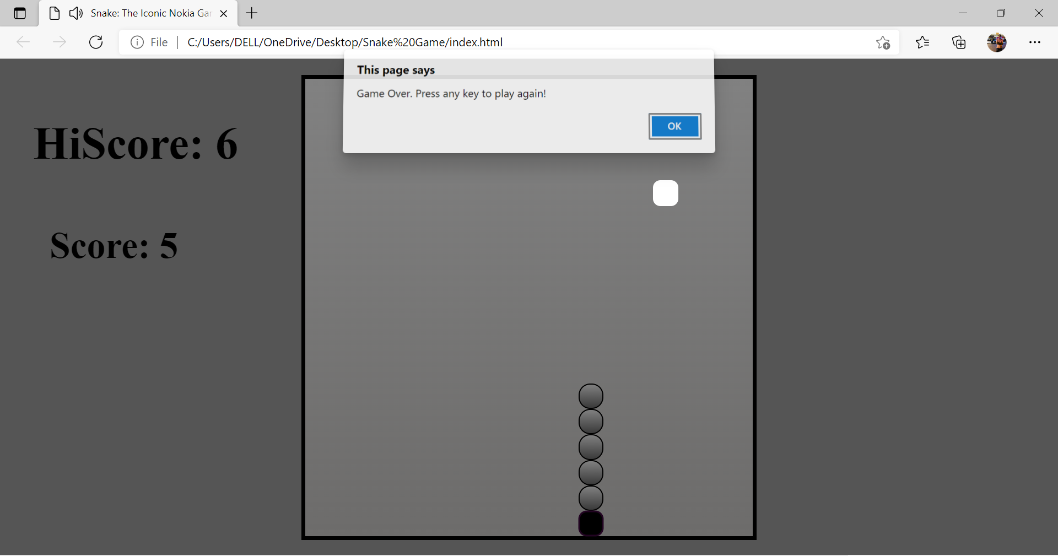

**Advantages:**

* Easy to Implement.
* Easy to Play.
* Hardware and Software requirements are minimal.

**Limitations:**

* The graphics of the Game are very Basic.
* The game does not have any feature of select level.
* Multiplayer functionality is not available.

**Future scope**

This game currently has a lot to get improved. But following are few of them which can be Updated in the near FUTURE for a better Experience.

**1.** It can be made with good graphics.

**2.** We can add more options like Top 5 scores and Player Profile.

**3.** We can make it to be played Online.

**4.** Add more difficulties or other interesting things.

**5.** Add multiple food items simultaneously**.**

**6.** The functions set could be modified to feature enhanced detection capabilities and more advanced navigations options.

**CONCLUSION:**

We have completed our Project SNAKE GAME and we learnt so many new things. We also obtained more experiences of WEBPAGE designing. Since it was the first time that we built a project using CSS, JS and HTML, a lot of problems were encountered during our work on the project.

Bibliography:

1. Code with harry (you tube channel)
2. StackOverflow
3. GeeksForGeeks
4. Tutorials Point